**AI ALGORITHMS**

**IMAGE LIBRARY FROM SCRATCH**

**MACHINE DEEP LEARNING**

**STUDENT NAME:**

**ADMISSION NUMBER:**

Motivation 2

Tasks 4

Supervised Learning Image Classification 8

Image preprocessing 8

Detection of an object 12

Create Image Library 18

Training/ Testing AI Algorithms 19

Output Results 21

Discussion 23

References 28

**Motivation**

Essentially, machine learning has been a categorical part of our daily implementation, we structure a more factorial area and determine an even complex method to structure real life problems. With this we can determine a prominent way to handle multiple instances of a problem with dynamic methods with such, each time these used methods implement an even better way of solving the problem. Structuring data into such formats can improve the logicality and implementation of the design such that each unification with the used libraries identifies a useful methodology structured by the essential need to factor the data. Data science and Artificial intelligence have been critical based on evaluation and up-voted goal that has been achieved through learning data. Each concept is based on the critical goal of modules within the intelligence to accomplish a simple and actual work bit by bit. This simulates a better way to accomplish a way more enormous task by combining these modules into one single structure of multiple structures. Generically most of the users create data sets, and it has determined by the language used. For instance, Python has been an applied language to harvest data. Data harvesting is one of the most critical supplied methods that have imposed a significant challenge to developers and data scientists in classifying critical data into essential data. Models evaluate the stricture of the data into conception designs that can be evaluated into accuracy determination with the model used. Identifying a research topic to complete a critical data analysis can be based on evaluating the multiple instances.

All instances used within the language's usability and applicability are based on the core hardware and software capabilities to handle critical data. The python library is embedded with a long stretch of libraries that sequence low-level applicability and way more complex system operating usability and applies all the conceptual structure based on the various evaluations. Each library covers a more critical pathway to evaluate all the conceptual design and stricture of the data based on the simulation of the applied concepts. Machine learning applies a conceptual way to iterate between the various methods of data and how to apply all the logical structures into a more capable design that can be used to mode and critically analyze a modern way to apply various decisions.

Data variables are interpreted by a preprocessed structure that enumerates them to structure even better functionality during the actual machine learning process. Scientists find this as the default process that enumerates the structure of the model and data precision so that later when the data features are being enumerated, we can identify the classification of the data based on the actual significant methodologies on the structure.

Multiple systems emulate the structure that is determined by data. The concept is based on actual learning of this data and making a spin on how to apply and model the data into critical decisions. The applications applied to structure these data are embedded in libraries that will simulate and apply capable methods to structure the data into the critical concept. The components that enable the intelligence and manipulation of these data structures are preferred through python data learning. The language used most to stricture the importance of big data is Python. Most of its methods are classified as critical; therefore, this enumerates better concepts posed by the data scientists applying the language. Most users applying the language find it literate and easier to apply the various instances that are supposed to model the data. There is critically a considerable barrier between the achievements of companies applying their models through uncleansed methods and companies that apply a significantly critical method through learned methods.

**Tasks**

The various implementation of the python libraries require a higher system requirement; therefore, these instances applicably pose issues to users with low system specification requirements. The PyPy environment tries to incorporate the various pending requirements with the ones existing with the system specification requirements based on the emulation of services wanted to be done. If the requirements are not met, the user will tend to a lesser version which will instantly still be supported by Python. Python has grown over the years; it has dynamically allocated better software modules that can be applied by adding and subtracting the existing software with better modules and deducting the unnecessary modules from the previous environments to supply better functionalities with the library usability. Most of the python libraries in current Python 3.10 are embedded in each other rather than in the Python 2.7 environment. Therefore over the years, we can determined that the python language is improving daily.

The structure and purpose of the paper are to identify the various usability of the python language and how it has been applied and used among the various users. Most of the content in the paper is applicable as determined by the various logicality and how it is being emulated in real-life structures. Each applicability of the various python libraries such as numpy, pandas and scikit-learn are just a sample of the various critical methods and functionalities that are emulated within the documentation to give a glimpse of the actual usability of the data and generalize the knowledge to the rest of the users who want to apply the concepts.

Based on the various features critically analyzed by these sectors, we get an augmented way to determine how robotics and other categorical implementation are determined. These applied methods enable us to grow scientifically and reach goals we cannot achieve over a shorter period. Therefore, the usability of these significant systems enables us to reduce a particular workload that can be determined by learning an environmental imbalance of a critical time section and determine how to evaluate the existing methods better. Determining a machine learning environment has been critical over the years; therefore, this has been a critical factor that needs to be solved.

Python, over the years, has been an interpreted language that has enabled scientists to perform the analytical study, augmented analysis and, more often, a more desirable way to learn at least anything with data science and machine learning. The manipulation of each concept based on critical evaluation of all the concepts and analysis breakdowns comes with the execution structure of the python codes that are single-threaded over the years with the use of CPython. Generically, this environment is based on concepts of hardware and usability, and extended code is stipulated to run on the CPU as a single thread and structure a code fails at the end of the execution. A replacement that has been redone over the CPython is the PyPy environment which has a structural way to stipulate all the conceptual designs of running the code.

Concerning the study of the dynamic applicability of the python language, most users emulate the data science and artificial intelligence structures based on machine learning. Most studies show that users determine how to use Python and apply a more conceptual way to try and learn their environments.

Computer science focuses on most concepts and applied sciences; therefore, most computer systems and applicability are structured as essential computer science fields. With the emergence of the various computer systems and AI support vectors, we can complement a way better method than structures the instances purportedly to emulate better instances in the computer science field. As one of the significant critical sections applied within the computer science field, artificial intelligence is emulated by various other categories that apply a critical-based methodology that tends to emulate other fields in the computer science field. Applying the various structures within the drawing board of an AI system, we can categorize a more specific instance of generally applied or critically usage of other methodologies such as machine learning, classified as classical machine learning or deep machine learning. These two methods are a whole class methodology of the computer science field and apply majority usability in other fields dealing with the computer science sector.

Python language generalizes the use of automation on system software s to perform tasks emulated at more significant limits. Each concept is based on how the system reacts to automated programs. Python significantly enables a user to perform automated structures that can structure a better way to simulate all the possible categories of the actual data set and also get the datasets on an online-based functionality and scrap the data from any online platform.

Conceptually these instances are one of the significant usability of the python language. Automation is distinctively one of a categorical implementation that is determined by what a user wants to apply or generalize. Datasets are also a definite implementation that most members of the python language community use to make a generalized evaluation of a data category. The most used methods of these data are gotten from online platforms. One of these methods is the Kaggle website which stores multiple identical datasets that anyone from a beginner can manipulate to the professional level.

Generically we are applying a conceptual view on most of the python library instances and the actual usage of the actual data formats. Each category is based on an actual simulation of how the user decides to interact with the system. Data learning requires the most accessible memory to store the variables using massive datasets. Python enumerates a greater logicality and usability that structures the way users use the libraries. Therefore, more excellent usability means more understandable code that can emulate speed and automation.

**Supervised Learning Image Classification**

The introduction of supervised and unsupervised learning is a definite implementation that structures can emulate to factor a specific dataset with a specific type of learning algorithm to classify or composite a particular method. Each structure is embedded in the logicality that comes with it. We can structure all the feasible studies by determining the data type before applying the algorithm, but still, we would not identify the actual specificity of the data trend. It might look like a time series; thus, we apply it to a cluster, yet the data might need a linear model to evaluate all the necessary models. It is critical to structure the model's importance and determine if the model applied is correct. As a data scientist, this is a critical step; thus, we need to stipulate all the logical evaluations.

**Image preprocessing**

Over three hundred python libraries are legitimately used to structure necessary curvature within the functionality of data scientists. Most of these language processing tools are embedded through the throughput of the python libraries, and therefore, some of them are complex as, for instance, some might be used in language processing, image segmentation, classification, and modeling, among other various structures. We will emulate several structures according to how they are supposed to be emulated. To structure a typo within the language, we need necessarily to structure a more comprehensible way to perform a classification of the model or instead emulate the various data structure we have.

Various fundamental structures make up the basic level of scientific structure and, more so, the basic implementation of the interactive environment usability that stabilizes the way users structure their performance. Each user has first to interact with the kernel indirectly to stipulate the various purposed they want to conduct. Each methodology is a critical process where all the implementation will be performed in these kernels. A kernel can be implemented on the system at any structure, and thus data learning and scientific computing can be achieved. Achieving a critical-based structure with the implementation of the theoretical analysis and essential functions will enable the user to achieve faster processing.

Scientific computing structures multiple uses of digital sources and dynamically allocates the sources to a specific structure to be read by any library embedded in Python and structures the usability that comes with it. Each logic is determined by what the user necessarily wants to perform; therefore, multiple selections can be made based on a determined topic to emulate the specific concept needed.

Most of the generalized methodologies are structured essentially by the methods provided by Python. Most companies retract to the application means that they can get to structure the necessity of the data and also apply various fiscal methods that will help them structure potential means to evaluate and reprocess their existing data into greater heights. As data is a significant key in data processing and scientific learning, we can categorize the use of available efficient ways and structure the capabilities of the concept of the data.

In theory, every implacability of the instances used by a user can be emulated by the structure the libraries pose. Each library has critical usability; therefore, the kernel purports to use the memory even significantly. Thus GPU kernel systems should be preferred to run this manipulation. A GPU system is a kernel-based component that can be added generically to the existing computer motherboard to purposefully run dynamic processing of the data and emulate the better data processing.

In the previous years, the users tried to incorporate the various languages to structure the usability of machine learning and emulate the precision methods. With a Python-based environment, users can now apply a more generic methodology that structures the even better methods and libraries assembled within the python libraries. With this, the other languages can then be generically used in other sectors and apply structures that can be used to support the learning environments.

Logically learning datasets with a language like c/c++ would require a lot of library import to structure the various essential slots just to read the data. This has been made possible by emulating the structure and performing fewer lines of codes to emulate a monumental task. Tasks in Python are interpreted line by line; therefore, a single line could perform multiple instances than that which could be written in another language.

1. **Data preparation**

Data Preparation is one of the methodologies structured to emulate the most features of the data. Most of the characterization of the dataset is structured during the preparatory section. Removal of NA values and instead of columns that cannot or will not be used in the dataset.

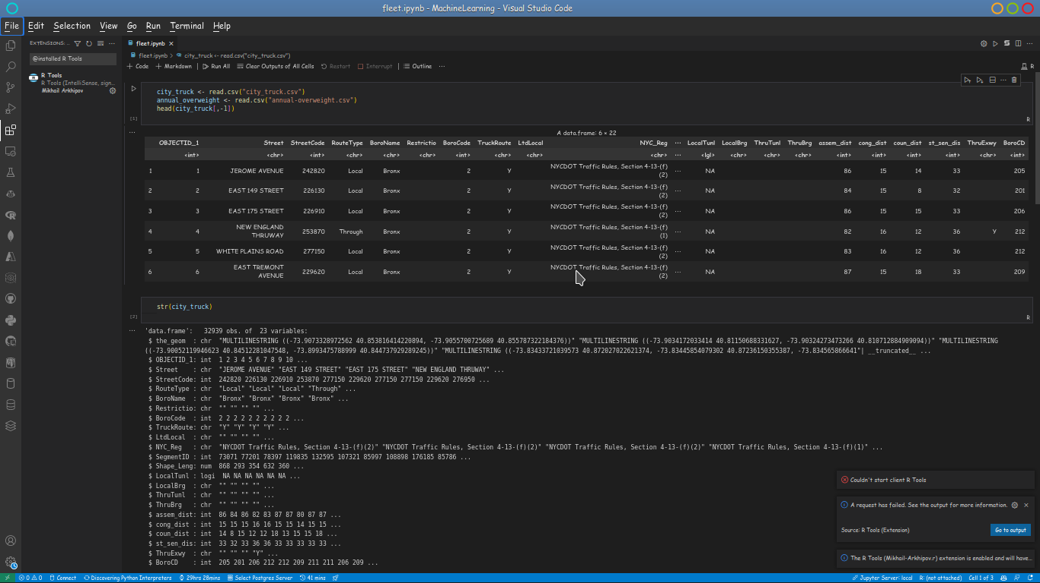

Some of the instances of loading and characterizing the folders are:

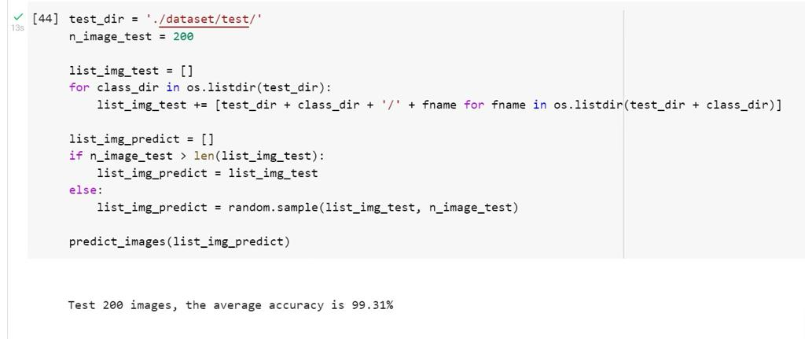

1. **Image resizability**

The parameters controlling the learning process are essential to the modeling and preparation. These values are primarily identical during the data processing and preparation. Some methods are used to control the essential behavior of the model. Each structure needs to be identical to the methodology determined.

Some of the methods that need to be applied as a checklist are:

1. Halving Grid Search
2. Randomized search
3. Grid Search
4. Manual Search
5. Bayes Search
6. **Augmentation** 
   1. **Scaling,**
   2. **Reflection**
   3. **Gaussian blurring**

The Gaussian model structures more categorically data with association to cluster the data. This model determines a normal distribution of the data and precisely mounts an actual deterministic value to determine the maximization potential of the model. It then distributes the endpoint data points and generically maps them to the actual feature relations. Each functionality is embedded by an infinite number of functions that approximate how each value will be factored; therefore, this sounds to be the most possible better probabilistic technique to cluster data. As clustering is considered, most of the actual functionalities can be made possible by evaluating all the logical structures and structuring all the logical values. The model clusters multiple numbers of spindles or rather groups and identifies them identically to the molded data evaluation to give a critical end value through the potential throughput of the data. Each logicality is embedded in the functionality of the relation, and therefore this is considered one of the significant fundamental values that are actuated within the model.

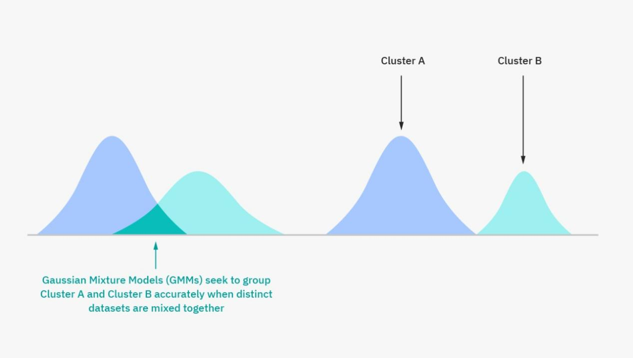

* 1. **Equalization with the use of historgrams**
  2. **Rotations**
  3. **Translation**

**Detection of an object**

Object detection is one of the various means that are used to determine the actual features that are within the read data. Most of the read images are structured and read so that we can identify the various objects in each image. Most of this is categorically performed by the following implementation. These algorithms structure and find an actual object using segmentation or any other method to structure the actual data from the image.

1. **Support Vector Machines**

In machine learning classification, we iterate over several instances; most instances can be categorized into supervised learning, while the rest can be categorized into unsupervised learning. Among these two classification support vectors is a supervised classification that outlines the classification and detection of mainly the healthcare industry to determine the existence of medicines and ways to categorize immunity and disease transformation. A better way to structure the way vector machines are used is by classifying each instance in the way it has required. Support vector machines are used to perform image segmentation and text categorization such that we can identify adherence to the subroutines set for specific medical treatments or, rather, medical dialysis of a particular disease. Each methodology is structured to compute a grid line of how to achieve various results and by what classification the learning will be of great potential. Most of the usability of the support vector machines is based on the conceptual design of factoring the healthcare industry and determining the logical ways to determine medications, symptoms and such.

**Vector Operations**

Most of the instances of vectors are used during the training of a model in machine learning; thus, with these operations, we can identify the target variable when modeling and training using an algorithm.

1. **Decision Trees**

AS determined above, machine learning is structured into various components and categories and therefore, the decision trees are just a type of structured and supervised algorithms that are structured to classify the efficiency and productiveness of the dataset and update each data tree bitwise and always ensure that the data partitions are updated continuously.

The features of the data structure are comprehended by the feasibility study that decision trees ensure a transient way to classify every parent and child tree branch and consistently update all these data partitions. Linear regressions are a component of data that determines most of the structures to classify the data.

Each formality is determined by the actual conditional structured statement that improves how the classification is made. The principal aim of determining the various positioning and actual classification of the data is based on the identical data partitions and also by what range the data is determined.

More essentially, we might have data based on independent variables or categorical data formats. Each data type variable still needs to be classified, and this algorithm favors and alternates its values to make a structural way to implement and structure the data into partitions.

Both the categorical variables and identical ones can be classified rather than being regressed to find the classified best model. Each independent classification of the data is based on the features of the condition and how they iterate over the classified instances. The branch and the tree are based on qualifying the conditions and iterating over the data partitions to perform the classifications.

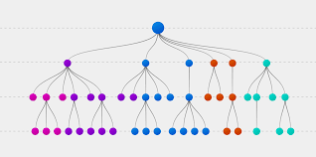

Machine learning with these algorithms equates to a better potential of getting a very productive mean score and achieving an actual model since the model algorithms structure each function to possessively structure all the data endpoints and partition them into branches and children with critical endpoints.

1. **KNN (K Nearest Neighbor)**

This is a machine learning algorithm that structures the classification methodology where its extracts a specific data point and their neighbors to perform the classification. Each methodology is based on the evaluation of all the endpoints of the data. The critical part is that we can identify an actual data category by the methods that are structured within the dataset. Each evaluation is based on the initialization of the model. The basic variable of the methodology is to functionality identify the actual objects neighbors and know the actual distance between the first object and the second so that we can factor out the various details from the images.

1. **Artificial Neural Networks**

Deep learning essentially structures the use of mimicking the behavior of an instance from a real-world functionality and structures them into solving complex data-driven instances. Most of the data is structured to model a more specific instance like speech recognition.

There are a multiple Neural Networks:

1. Feedforwarding artificial neural networks
2. perceptron and multi-layer perceptron neural networks
3. radial basis function artificial networks
4. recurrent neural networks
5. modular neural networks.

The use of GPU systems alters the way memory creates and buffers images in memory. Most of the circuitry is intended to output the display device; thus, these systems hold up a majority area in the performance of machine learning models.

Multiple instances of GPU systems are comprehensibly mapped to provide a GPU accelerated machine learning version that will help in the creation of imagery and also structure the analytic libraries used to perform the various instances needed.

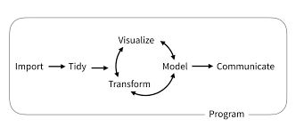

The building of algorithms that learn from the existing models as iterated above, most of these systems determine the observed instances, model them and structure a more equivalent better way that will emulate a real-world instance into solving complex problems.

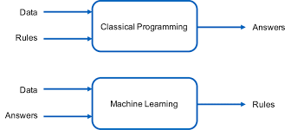

Most libraries use N-Dimensional arrays to represent the data format and structure them for visibility. These instances are numpy-ml instances, which are used to display the data.

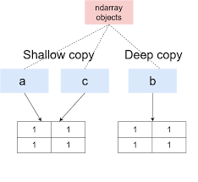

CNN is a categorical deep learning algorithm that structures the essential use of weights and biases on image sets that are inputs and structures them into different aspects and objects from one another. With the classification of images with the other algorithms, we can structure multiple computer vision objects and structure them eminently to convert them into objects and structure their functionality differently

Most data endpoints are critically based on how a model evaluates them. In this algorithm, we are structuring the essential structures to the most k-group and assigning several clusters based on the distance they relate to the central part. The evaluation of most of these can be explained in this manner.

The cluster of the model is a single span of a network model that attenuates in a spindle, and not the clusters are moved within a spindle and correlated to the center most point and this, each cluster is made according to the one nearest to the center of the group.

**Create Image Library**

Based on this description, most of the analysis will be based on the features of the data and evaluated by the factors of the data models and the k-groups, which later will be graded by the means and structures. Evaluating this is critical because it has supposed to be done manually; thus, this is where the python modeling language comes in. The Python language handles each algorithm superseded within this documentation using multiple libraries. Each of which can be identical to the structure needed.

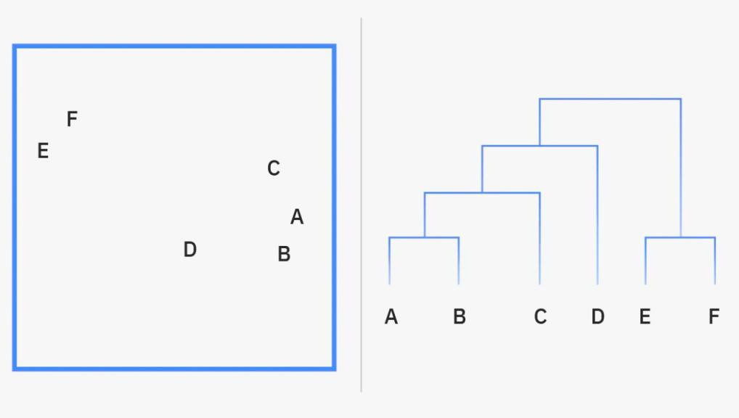

With multiple images and structures we need to evaluate a number of instances and therefore to structure a more readable dataset we extract the various features from out dataset images. We then factor the necessarily functionality and emulate better performances with the structure.

Creating a model iterates a critical part of most system evaluations. Most of the time, we are determining an actual instance in a dataset, evaluating the critical points necessary to factor out classical methods for the majority and minority classes to build a better accuracy; when most of these instances are not factored correct, we will get great accuracy. Nevertheless, this accuracy is only factored in the majority classes, not the minority classes. This will cost us more since the accuracy has not been dynamic during our model processing. To structure this problem, we can identically use the following means to perform score generation.

Metric maps can be used to identify the logicality of the score. With this, the accuracy score models can be used to find the actual score of the accuracy generated.

1. **Resampling techniques**
   1. **Oversampling**

It indicates the duplication of records from the majority class to the minority class. This, for instance, can cause overfishing.

* 1. **Undersampling**

Removing any random records from the majority class can cause a loss of information.

**Training/ Testing AI Algorithms**

Critical generation of a model of a single dataset can be mapped with multiple data models from the same data into predictions that come from the model. These predictions are then structured like the current training data or instead as the same type if they are supposedly used to get a more iterative model from the data.

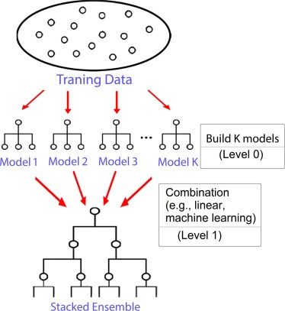

**Scalable Distributed**

Most of the data generated by the various systems are huge; thus, these data need to be asynchronously mapped into a dimensional structure, and therefore most of the structure can be mapped to analyze a non-parametric dataset collectively.

In the current applicability of the python language, we find that most other languages are interconnected to the functionality of the python language processing from databases to other languages. Necessarily, performing classification with JSON data, we can emulate the use of JavaScript to embed the data into JSON categorically and let Python read the data set singularly from top to bottom.

On the other hand, XML files can be read by Python by listing the details in the directory and determining the library to use to read the JSON files by importing JSON **(import JSON).** Logically we can interpret any other language and embed it into Python, and necessarily we are emulating a comprehensible way to structure the complete emulsion of Python into another language and structure it to perform the logical implementation. Previously, none of this was made possible since most of the usability was concentrated on developing other instances before python analysis was performed.

**Output Results**

The interest in applying the python language with other languages is to precisely embed the characteristics that Python possesses into other languages and embed the functionality of other languages into the python language. We can iterate this through the logicality that the python language will be processed and interpreted as it has supposed to while the other languages are compiled.

Compiling Python into another compiler will cause problems, but that is not the point. We are necessarily combining a logic of python usability and applying generic means to run the python environment into other language environments and expect a critical output that will benefit the performance of the data being assessed.

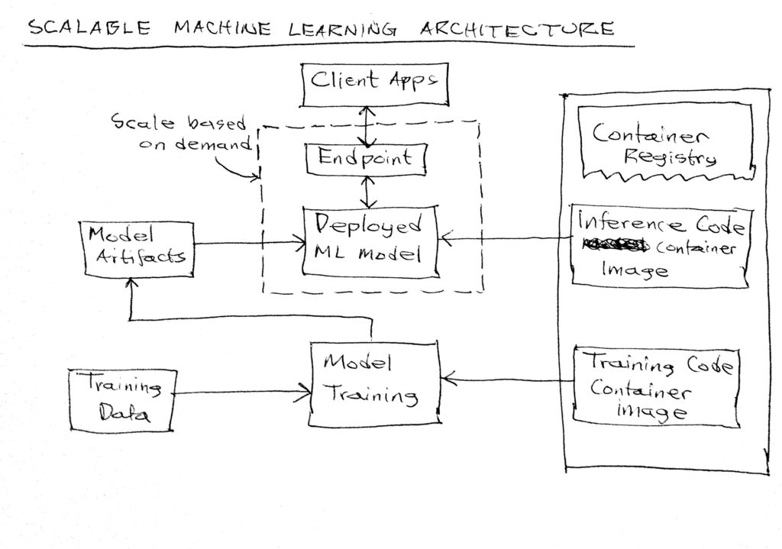

Most systems use input and output structures to determine an outstanding output from the existing implementation. Most of these logical structures are being implemented as they are logical; therefore, most of it is structured to determine the actual functionality during the process determination. Most of these systems use the existing observation to structure output, use the existing observation from existing datasets, determine the actual variables, and predict newer observations based on existing ones.

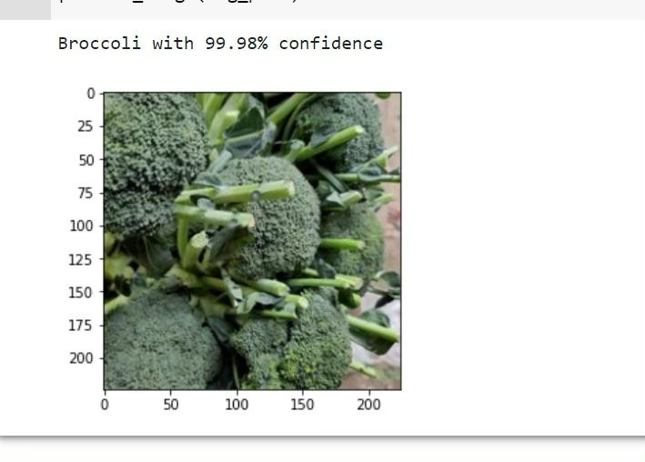Creating a model iterates a critical part of most system evaluations. Most of the time, we are determining an actual instance in a dataset, evaluating the critical points necessary to factor out classical methods for the majority and minority classes to build a better accuracy; when most of these instances are not factored correct, we will get great accuracy. Nevertheless, this accuracy is only factored in the majority classes, not the minority classes. This will cost us more since the accuracy has not been dynamic during our model processing. To structure this problem, we can identically use the following means to perform score generation.

They use machine learning and Artificial intelligence to solve real-life problems. Most of the characterized datasets can be mapped to structure a more consistent data platform and initialize all the consistent variables towards a structural model to be used in a real-life problem. Each is essential to factor in the most critical areas and discard the unnecessary formats that are not needed.

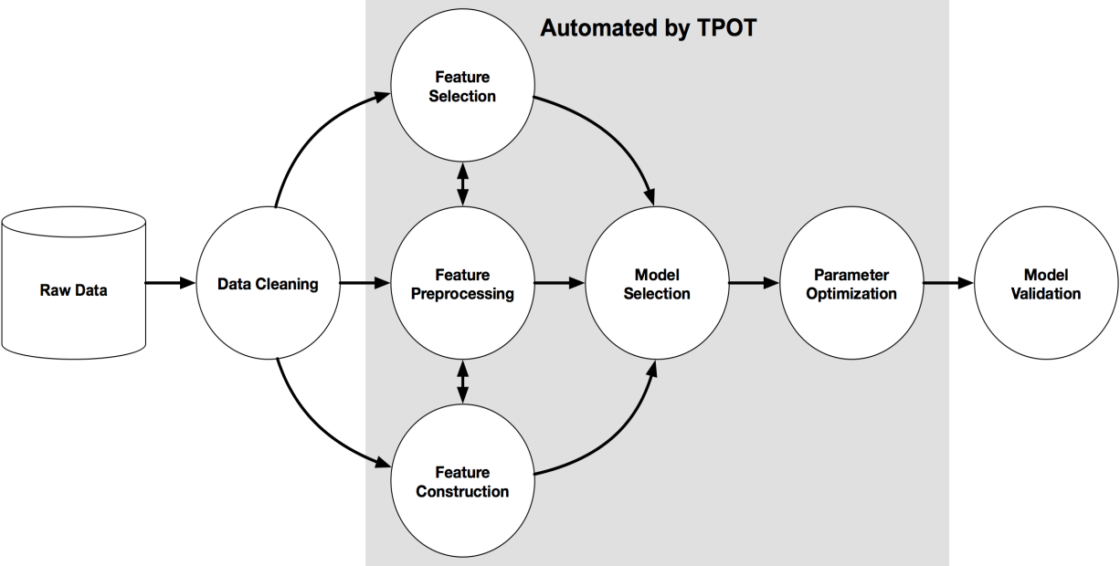

## **Discussion**

A variety of analyses can be based on supervised or unsupervised learning. This characterizes all the feasible structures to determine an actual range of the data features and enables a user o independently determine an actual model to structure the data. In most instances, we can structure the potentiality of the data by how eminent can be structured through the feasible functionality of the data.

Given a data-driven segment as the actual source of data, the generic requirements to hold a particular type of data like that will require much greater memory storage that will hold all the limits of the data as the drive into the visualization. This is critical as the system's requirements will require much time to process a certain kind of data. The variable names and all the instances that come in as input and the threaded modeled data would need to be stored. Each structure satisfies all the requirements that are necessarily needed.

Based on how each scientist classifies their data, we can determine that the first-class step is always to visualize and process the data to determine which variables would be used as factors during the process, or rather which variables would be used to identify the actual dataset group and also sample the data into test and train during the whole machine learning process. We can equate the process into structural and variable-based instances that will ensure we have the correct instances during our preprocessing.

Each step is based on an independent or dependent variable, and we can then classify the sampled data into training and testing datasets within the same dataset. During processing, most scientists process the data into clean variables, structure the essential means, and remove null values. The directed way to manipulate the feasible means is to identify all the logical structures. It is evident how this will help structure the data more logically.

Structuring an essential data stretch according to machine learning, one might need to classify all the essential factors of a model and ensure that all the features are fiscal. At other times a scientist might encounter a time series dataset. These data have a variable that can independently change the data into a time series dataset, converting the rest of the data based on the date factor and can be plotted using a regression of a scatter plot.

Visualization is one essential involvement that needs to be used to structure the data and ensure that all the critical functionalities are laid out before the actual modeling and classification are performed. Factoring the essential parts needs an actual potential structure first to visualize a dataset's endpoints and the critical sectors of the data. The virtual that comes with data processing is that identical forms can be pre-shared between the columns, and one has to determine the actual columns they have to deal with and necessarily remove them before continuing to perform the various validation.

This reduces the number of variables stored within the memory and gives the scientist a better capability to structure a precise model. Precision is critical, and one would always want to work with a lesser data format, and thus, data cleaning is another critical process that is required between the instances.

**Conclusion**

The feasibility study is evaluated by continuously determining the actual structure of the previous works. We can evaluate all the necessary factors and the naturalism of the previous tasks and embed our analysis based on the critical sections. Python being a primary initialization, we are sure to interpret most of the codes and evaluate the consistent structure of the algorithms and how they are potentially mapped in daily functionality.

Critically one can analyze all the functionality of a data set through a machine learning model, whether unsupervised or supervised learning. Each concept is based on the features of the data and how actual the data levels are being factored in. Aligning the critical sections of an interpretation can be feasible. Therefore some factors can be embedded in the type of variables, type of characters embedded within the data concept and how each is being manipulated concisely. Based on the various data interpretation, we are logically featuring all the advanced levels of the data and formulating newer ones to structure a more dynamic way to perspective categorize each of them.

The formulation of the actual dependent and independent data variables can be reliable when made feasible by the design and classification of the data. Each consistent structure is factored by how it has supposed to be partitioned and made actual through the algorithm. Most scientists classify a dataset by the way each variable is aligned through the dataset. Formulating all the structures can be reliable, and such helps the data scientist determine the actual algorithm that can be used to identify the classification or outlier management of the data.

We can then determine the actual errors and get a consistent way to factor the input and output of the data partitioned and also visualize the data methods. The model algorithm will independently be based on the type of data we are learning and by what output we want to get at the end of the learning.

Machine learning has simpler categorical feasibility that enables most users to get an independent characteristic of the data and determine an actual generalization of the whole dataset by listing the columns, structure and type of the data variables within the data.

Consistently we can generalize these methods to the first prepossessing methods a user initializes to determine the actual determinant method based on the feasibility and round-table determination used by the user. An actual independent characteristic can be determined if the variables are string variables or instead if they are integers and actual features that are characterized by the logicality of the feasible structures.

The methodology is then to structure the independent factors that can be used to generalize and make a feasible structure to model the data. Determining the actual data models using train and test datasets enables the algorithms chosen to extract the model using the same data lengths and determine an actual prediction and outliers based on these features.

Categorically we can instantiate all the various prepossessed ways and determine the RMSE using the actual models used. Not all models can enable you to get the actual standard error, while some can enable one to get an accuracy feature based on the data's consistency.

Based on the feasibility study of the data, we can generalize all the potential characteristics of the data outliers and get an actual accuracy of the model depending on the modeling structure. It would be helpful if one identifies a logical structure and manipulates all the feasibility methods to structure a potentially better model through data visualization.

## **References**

Balyen, Lokman, and Tunde Peto. "Promising artificial intelligence-machine learning-deep learning algorithms in ophthalmology." *The Asia-Pacific Journal of Ophthalmology* 8, no. 3 (2019): 264-272.

Jordan, Michael I., and Tom M. Mitchell. "Machine learning: Trends, perspectives, and prospects." *Science* 349, no. 6245 (2015): 255-260.

Mohammed, Mohssen, Muhammad Badruddin Khan, and Eihab Bashier Mohammed Bashier. *Machine learning: algorithms and applications*. CRC Press, 2016.

Fatima, Meherwar, and Maruf Pasha. "Survey of machine learning algorithms for disease diagnostic." *Journal of Intelligent Learning Systems and Applications* 9, no. 01 (2017): 1.

Panch, Trishan, Peter Szolovits, and Rifat Atun. "Artificial intelligence, machine learning and health systems." *Journal of global health* 8, no. 2 (2018).

Sarker, Iqbal H. "Machine learning: Algorithms, real-world applications and research directions." *SN Computer Science* 2, no. 3 (2021): 1-21.

Bini, Stefano A. "Artificial intelligence, machine learning, deep learning, and cognitive computing: what do these terms mean and how will they impact health care?." *The Journal of arthroplasty* 33, no. 8 (2018): 2358-2361.

Kaplan, Alan, Hui Cao, J. Mark FitzGerald, Nick Iannotti, Eric Yang, Janwillem WH Kocks, Konstantinos Kostikas et al. "Artificial intelligence/machine learning in respiratory medicine and potential role in asthma and COPD diagnosis." *The Journal of Allergy and Clinical Immunology: In Practice* 9, no. 6 (2021): 2255-2261.

Sarker, Iqbal H. "Machine learning: Algorithms, real-world applications and research directions." *SN Computer Science* 2, no. 3 (2021): 1-21.

Sha, Wuxin, Yan Li, Shun Tang, Jie Tian, Yuming Zhao, Yaqing Guo, Weixin Zhang et al. "Machine learning in polymer informatics." *InfoMat* 3, no. 4 (2021): 353-361.